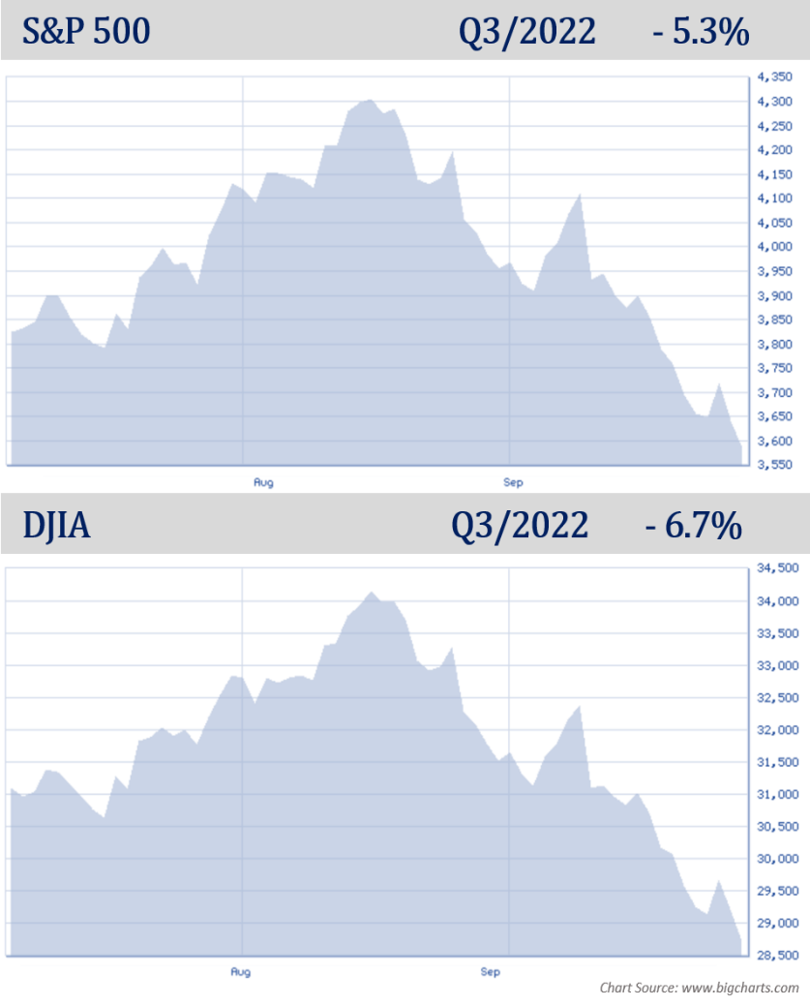
Quarterly Economic Update Third Quarter 2022
Investors understand that markets go up and also go down. After being treated to better than average returns for over a decade, 2022 has been a year that has tested even the most seasoned of investors. This year, investors have experienced frequent bouts of market-moving news, combined with reports of slowing economic growth, elevated inflation, and weakening fiscal and monetary stimulus. In response, by the end of the third quarter, the S&P 500 index tumbled more than 22% from its record high, and bonds have lost around 14% since January. Investors have seen huge market volatility in response to many reports including those on monthly inflation, jobs numbers and every utterance of Federal Reserve officials. With that type of backdrop, it can be easy for investors to get caught up in the here and now. Having said that, the most successful investors still acknowledge that investing success can be most consistently achieved with a long-term perspective.

The third quarter of 2022 was a very rough one for equities. September’s quick drop left the S&P 500 down 5.3% for the quarter. This marked a 52-week low, and September was logged as the worst performance for the S&P 500 since March 2020.

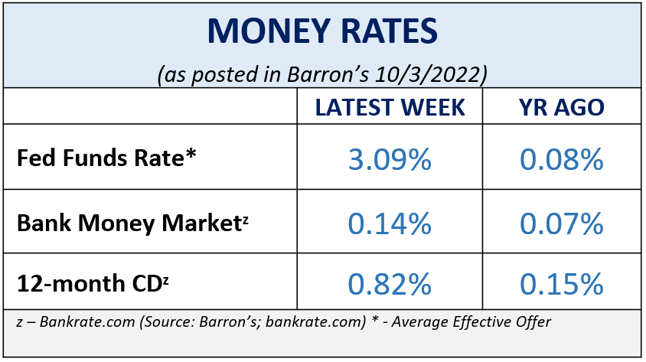
The Dow Jones Industrial Average (DJIA) also set a 52-week low, closing down 6.7% for the quarter. This marked the third consecutive quarter decline, bringing it down 21% to date for 2022. Similar to the S&P 500, the DJIA experienced its worst month in September since the pandemic-driven lows in March 2020. After a long hibernation, with a few peeks outside, it looks as if the bear has officially come back to the equity markets.

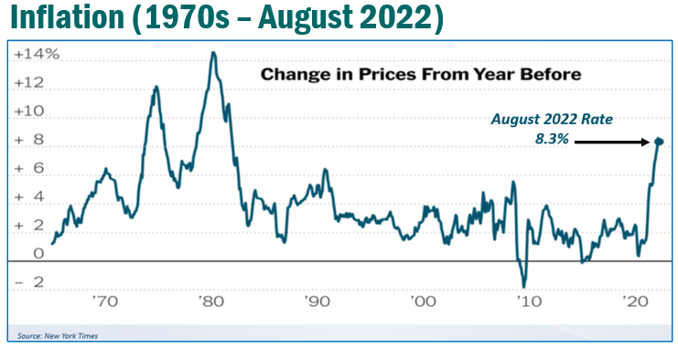
The annual inflation rate for the United States was 8.3% for the 12-months ending August 2022. Americans continued to feel the pinch as fuel prices and grocery receipts remained markedly higher. During the quarter, first-time unemployment claims hit a 4-month low, which is both good news and bad news. The good news is more Americans have jobs, the bad news is the Fed, which takes unemployment rates into consideration when making adjustment, is likely to continue their aggressive tactics against inflation.
KEY TAKEAWAYS
- The Fed raised interest rates 0.75% in September and indicated it will keep increasing rates until inflation is defeated.

- Recession concerns are on the rise.

- Treasury yields are providing higher returns.
- Geopolitical unrest remains a key worry.

- Volatility is a key factor in this economic environment.

- Bear markets are a normal part of the investment experience.
- Staying the course and maintaining the consistency of a well-devised plan has historically served investors well.

- We are here for you to discuss your situation.

There are always multiple factors that need to be watched that can directly affect equity markets. Here are four concerns that could be major factors in impacting the direction of equity markets at this time:

The continuation of rising inflation rates. The inflation rate is still not losing steam despite the Fed’s efforts. All eyes are on the Fed’s movements to combat inflation.

Further interest rate increases. The Fed’s key solution for fighting inflation is to raise interest rates. To date, their efforts have not produced satisfactory results. Interest rate increases this year have been consistently followed-up by a decline in equity markets.

Geopolitical unrest. Equity markets do not like uncertainty and with the ongoing war between Russia and the Ukraine and concerns over a major conflict with China and Taiwan, geopolitical unrest continue to be something we are keeping a watchful eye on.
Recession concerns. There is a lot of talk about a recession. Fears that the Fed’s aggressive moves will plunge the economy into a deep recession have been a continual news headline. A recession is technically defined as having two successive quarters of economic decline. Empirically, we are in recession territory. However, with employment numbers still in good shape, decent economic earnings, and the housing market still healthy, the economy still has some areas of strength.
Fed Chairman Powell addressed recession fears following the September FOMC meeting. He shared that, “No one knows whether this process will lead to a recession or, if so, how significant that recession would be.”
Regardless of whether we indeed will experience a severe recession, investors should understand that volatility is likely to be here for a while.
As your financial professional, we are committed to keeping you apprised of any changes and activity that could directly affect you and your situation. Now is a key time to practice patience and resilience and to remain focused on your personal, long-term goals.
Inflation & Interest Rates
This year, we have experienced the fastest rise of inflation since the 1980s. Despite the Federal Reserve’s efforts to slow down this runaway train, inflation is still strong.

At the September Fed meeting, in their continued efforts to combat public enemy #1, the Fed’s interest rates were once again increased by 75 basis points (or 0.75%) for a target range of 3.0% to 3.25%. This marked the third time the Feds have raised rates by 75 basis points and the fifth time they have increased rates in 2022.

Equity markets responded negatively to this news. The DJIA closed the day down 522.45 points (or 1.7%). The S&P 500 dropped 1.71% and after the close on that short announcement day in September, was down more than 10% for the past month and 21% from its 52-week high. (Source: cnbc.com; 9/20/22)
Inflation is a real concern for Americans because it eats into our purchasing power and lifestyle. Anyone who drives, eats, turns on the lights, swipes a credit card, or has living accommodations, is experiencing the effects of inflation. The four major area most Americans are seeing the pressure is at the grocery store, the gas pump, their electricity bill – and in housing costs, whether you are renting or buying.

It’s very possible that interest rates above the last few years historically low rates will be here for some years to come. Since the 2010’s, American had been enjoying these historically low interest rates. Now, interest rates are front and center as the Fed stands by its commitment to combat inflation.

We continue to suggest that, if you haven’t already done so, to take a look at these areas of your financial situation:

- proactively pay off all non-essential interest-bearing debt,
- maintain liquidity for short-term purchases,
- if you have a mortgage, lock in your rate,
- If you have bonds in your portfolio, understand the duration of them, and
- review all income-producing investments.

As your financial professional, we are committed to keeping a vigilant eye on all aspects of financial planning that may affect you. Interest rates will continue to be near the top of our watchlist.

The Bond Market and Treasury Yields
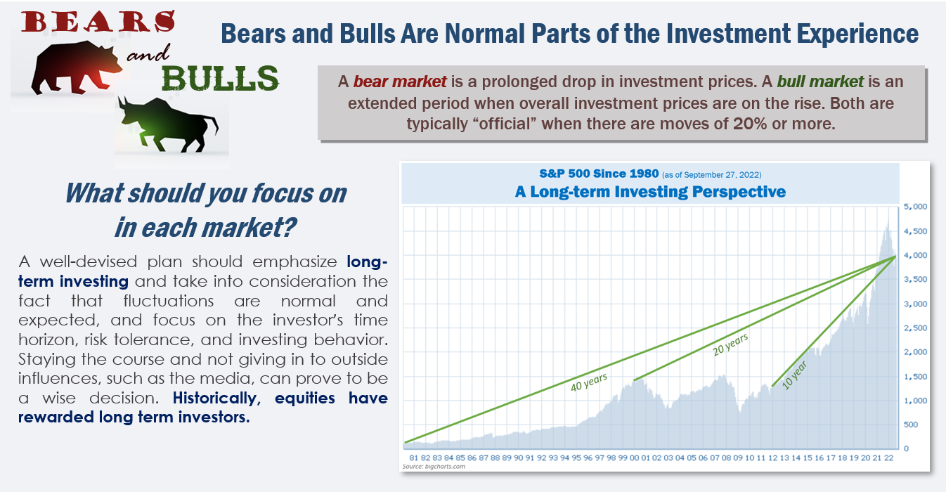
As of September 30, 5-year notes yielded 4.06%, 10-year notes yielded 3.83%, 20-year notes yielded 4.08%, and 30-year notes reached 3.79%. The benchmark 10-year Treasury note had not seen these rates for over 12 years, when it reached a high of 3.93%. The 2-year treasury reached 4.30% on September 27, which is the highest it has been since August 2007.
Bond investing can be challenging and the opportunity to take advantage of favorable bond yields could be brief. Also, please remember, while diversification in your portfolio can help you reach your goals, it does not ensure a profit or guarantee against loss.

Bonds which have historically been held by investors as a balance to equities have had a very rough ride in 2022. When rates go up existing bond prices go down. Longer term bonds tend to be the ones most affected, so investors need to watch the duration or length of the bonds they hold. We are monitoring how the Fed’s movements and rising interest rates are affecting bond yields.

Investor’s Outlook
No one can predict the next 5, 10, or 50 years for investors. While past market results do not forecast future performance, it is helpful to look at history. During the 50 years from 1970-2019, there were seven recessions, 10 bear markets and four distinct market crashes with losses in excess of 30% for the U.S. stock market. If you go back even further to the previous 50 years from 1920 to 1969, there were 11 recessions, 15 bear markets, and eight distinct market crashes with losses in excess of 30% for the U.S. stock market. In other words, bear markets are a very normal and reoccurring part of the investment experience. Since 1930, the market has been bearish for about 20.6 years. Conversely, this means that stocks have been favorable the other 72 years!
From March 2009 to March 2020, we experienced the longest bull market in history. According to calculations on the website www.officialdata.org, if you invested $10,000 right before the bull market began in 2009, by 2020, that $10,000 would be about $55,817, or a hefty 458% return on investment or 15.41% per year. As billionaire investor and businessman Charlie Munger stated, “It’s waiting that helps you as an investor, and a lot of people just can’t stand to wait.”

Until there are signs of slowing growth, the Fed will continue to charge forward on their fight against inflation. With that, and the markets response to the Fed’s bold moves, recession woes will continue to be front and center. Wise investors have well-devised plans that take into consideration potential volatility so that there are no surprises when market fluctuations inevitably happen. While no one knows what each year brings, here are some strategies that investors should consider:

- Focus on your time in the market, not trying to time the market. Historically, equity investors who focus on long-term goals and remained faithful to their personal, well-crafted plan have been rewarded. Remember, investing in equities should be viewed as a long-term commitment!
- The cost of borrowing is continuing to rise. A good rule during rising interest rates is to maintain liquidity for any larger purchase you know or think you will have in the near future.
- Keep a level head and clear perspective. It’s easy to experience anxiety over today’s current environment, particularly if you listen to the news and read the headlines daily.
Complimentary Financial Check-up
Our goal this year is to help others with their financial decisions.
If you are currently not a client of Wealthbuilders Financial Group, we would like to offer you a complimentary, one-hour, private consultation with one of our professionals at absolutely no cost or obligation to you.
To schedule your financial check-up, please call SARAH at (727) 843-0151

- The current cycle we are experiencing may take some time. That is why we recommend proceeding with caution. Please call our office to discuss any concerns or ideas you have or bring them up at your next scheduled meeting.

These are challenging times for investors, and we want you to be comfortable knowing that we are staying apprised of any issues that may affect your situation. Having a proactive approach to your financial goals and a solid investment strategy is part of the overall experience we offer to our clients. As always, please feel free to connect with us with any concerns or questions you may have.

A skilled financial professional can help make your financial journey easier. Our goal is to understand your needs and create an optimal plan to address them. While we cannot control financial markets, inflation, or interest rates, we keep a watchful eye on them. We can discuss your specific situation at your next review meeting or you can call to schedule an appointment. We appreciate the opportunity to assist you and your financial matters.

James M. Noto, CFP is a Registered Principal offering securities and advisory services through Independent Financial Group, LLC, a registered broker-dealer & registered investment adviser. Member FINRA/SIPC. WealthBuilders Financial Group Inc. and IFG are unaffiliated entities. This article is for informational purposes only. This information is not intended to be a substitute for specific individualized tax, legal or investment planning advice as individual situations will vary. For specific advice about your situation, please consult with a lawyer or financial professional. Note: The views stated in this letter are not necessarily the opinion of Wealthbuilders Financial Group, LLC, and should not be construed, directly or indirectly, as an offer to buy or sell any securities mentioned herein. Investors should be aware that there are risks inherent in all investments, such as fluctuations in investment principal. With any investment vehicle, past performance is not a guarantee of future results. Material discussed herewith is meant for general illustration and/or informational purposes only, please note that individual situations can vary. Therefore, the information should be relied upon when coordinated with individual professional advice. This material contains forward looking statements and projections. There are no guarantees that these results will be achieved. All indices referenced are unmanaged and cannot be invested into directly. Unmanaged index returns do not reflect fees, expenses, or sales charges. Index performance is not indicative of the performance of any investment. The S&P 500 is an unmanaged index of 500 widely held stocks that is general considered representative of the U.S. Stock market. The modern design of the S&P 500 stock index was first launched in 1957. Performance prior to 1957 incorporates the performance of the predecessor index, the S&P 90. Dow Jones Industrial Average (DJIA), commonly known as “The Dow” is an index representing 30 stocks of companies maintained and reviewed by the editors of the Wall Street Journal. Past performance is no guarantee of future results. CDs are FDIC Insured and offer a fixed rate of return if held to maturity. Due to volatility within the markets mentioned, opinions are subject to change without notice. Information is based on sources believed to be reliable; however, their accuracy or completeness cannot be guaranteed. There is an inverse relationship between interest rate movements and bond prices. Generally, when interest rates rise, bond prices fall and when interest rates fall, bond prices generally rise. There is no guarantee that a diversified portfolio will enhance overall returns out outperform a non-diversified portfolio. Diversification does not protect against market risk. Sources: www.cnb.com; www.cnn.com; www.fidelity.com; www.barrons.com; www.officialdata.com; www.bigcharts.com. Contents provided by the Academy of Preferred Financial Advisors, 2022©
No investment strategy can guarantee a profit or protect against loss.

