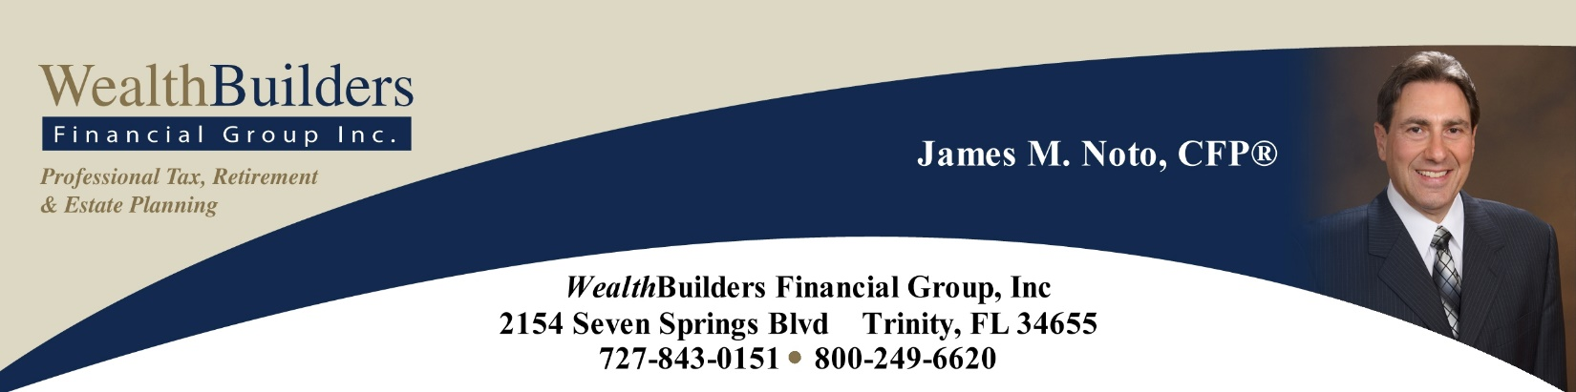

There Is Always a Reason to Be Grateful!

We believe the best client is an informed client. For this reason, throughout the year we provide our clients with a wealth of consistent and pertinent information on financial topics and markets conditions, including quarterly reports, tax reports, and articles. Our goal is to provide helpful, timely and meaningful information that is relevant to our clients’ personal situations. We also take pride in offering first-class service to our clients and are truly thankful for each and every one of our relationships.
2022 was a challenging year for investors. After over a decade of healthy returns, investors experienced declines in almost all areas of investments. As the holiday season arrives and the year ends, we like to shift our focus and share with you a message we feel is very important, especially in these times of volatility and uncertainty – two things the world has had its fill of this year. Our message for this article is gratitude.
Psychology Today says that, “Gratitude is the expression of appreciation for what one has. It is a recognition of value independent of monetary worth.” The publication also cites that, “Gratitude is a spontaneous feeling but, increasingly, research demonstrates its value as a practice—that is, making conscious efforts to count one’s blessings.” Studies show that people can deliberately cultivate gratitude—and there are important social and personal benefits to doing so. Each and every day we have an opportunity to embrace and share gratitude. Harnessing a feeling of gratitude and carrying it with you through the year - making it a habit - can be a powerful shield in times of difficulty. Remember – gratitude can help with happiness, and happiness matters!
What is Your Gratitude Strategy?
One way to elevate your gratitude strategy is to be aware of where you place your focus. Even in negative situations, you can always choose to focus on the positive side of every situation, commonly referred to as the “silver lining.” Even our greatest difficulties provide the seed for equal and greater opportunity. A setback can easily be viewed as a chance to make a comeback. Your greatest struggle can become your greatest victory, if you choose to focus on what good is happening around you rather than the bad.
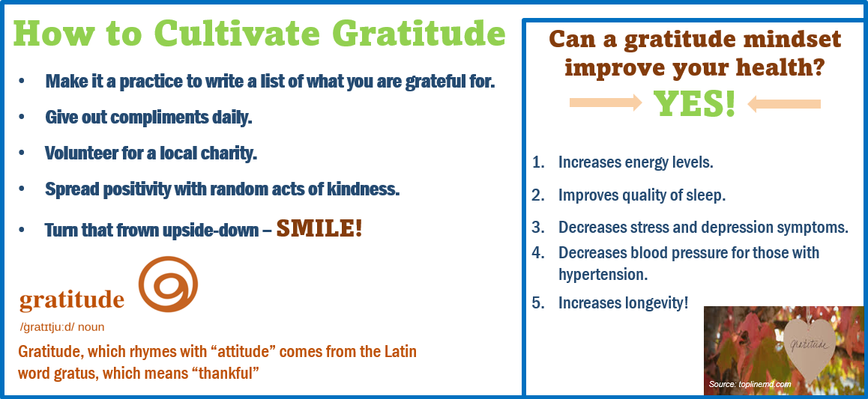
Many people start to realize when you change the way you look at things, the things you look at begin to change. Everyone understands that we cannot choose what happens to us, but we can always choose how we react. The only thing that we continuously have full control over is the power of our own minds.
For example, you can’t control the weather, just like you can’t control someone else’s attitude. However, you can choose how you react to situations and can choose to act with an attitude of gratitude.
A plane is delayed due to inclement weather. There are two people at the airport. One chooses to get very angry and complain to the staff and other passengers. That person sits with their arms folded and focuses on all that's wrong with this situation. Their meetings are going to either get cancelled or pushed back. Their ride from the airport is going to leave. Their evening plans are going to be missed. Taking an angry and rough outlook fuels anxiety and unnecessary stress within yourself and those around you.
Another passenger scheduled for that same flight smiles and pulls out their laptop. They use this as an opportunity to get ahead on some work. They thank the attendants as they scramble to make sure everyone is accommodated. They make phone calls and reschedule for when they are now expected to arrive. They think about the fact that it is much safer to wait. They acknowledge that flying, even in good weather, is never easy – and safety can be compromised during a storm. They see this as an inconvenience, but they have adopted an attitude of gratitude.
The difference in these two passengers is not their situation. It is their attitude, their perspective, and their focus. Choose gratitude.
Can you be grateful during
tough times?
This was a tough year for investors. After many healthy years, equity markets and bond markets both saw declines. Gratitude can be helpful when you are trying to make wise financial decisions. We believe that focusing on longer-term investing provides more flexibility than attempting shorter-term horizons. Of course, even when investing long-term, there is no guarantee that market volatility will decrease, increase, or stabilize in any timeframe. A study that Psychology Sciences released revealed that participants who expressed gratitude were more likely to generate better results than those who looked for immediate gratification. The research found that those who expressed gratitude appeared to display more patience and happiness with their current situation. The study also revealed that those who had more feelings of gratitude were able to reduce impulse buying, due to more overall contentment, and were less reliant on the high that immediate gratification can provide. (www.forbes.com, 11/25/2019)
In terms of investing, gratification and patience can be useful when focusing on your time horizon, especially during times of volatility. Remember, equities are considered long-term investments. Historically, it’s not uncommon for equity markets to drop over 10% or more during a shorter period of time. Investing for the long-term can help investors stay on track during turbulent times to ride out market volatility, thus potentially achieving their original goals. Contentment is a result of gratification.
Securing your investments will help reduce panic and rushed decisions that may not be in the best interest of your portfolio. Our role as investment professionals is to help you understand your situation, because an educated client is our best client.
In the spirit of the season, we want to express our sincere gratitude for the trust you place in us as stewards of your wealth. As always, we are here to help and are available to review your situation. We will always consider your goals as well as your feelings about risk and the markets and review your unique financial situation when providing any recommendations.
Included in this article is a brief form to help you evaluate what you define as “wealth.”
In the coming year, we will continue to provide you first-class service, including:
- consistent and effective communication,
- regular client meetings, and
- continuing education for members of our team on the issues that affect you.
We understand that having a good financial professional can help make your journey easier. As such, our commitment is to understand our clients’ needs and try to create plans to address those needs.
So, for 2023, let’s try to intentionally include gratitude! As always, we appreciate the opportunity to assist you with your financial matters.
We’d like to expand our family!

We are grateful to have clients like you that value our expertise. We take pride in the services we offer and the relationships we have cultivated throughout the years.
We want to help others like you in 2023!

Do you know someone who could benefit from our services? If so, please contact us so we can offer them a complimentary, one-hour private consultation to explore their personal financial situation.

To connect us with a friend or family member who you think could
benefit from our services,
please call SARAH 727-843-0151!

“True” Wealth Goals for 2023
Health Wealth
- _________________________________________________________________________________________________________
- _________________________________________________________________________________________________________
- _________________________________________________________________________________________________________
Emotional Wealth
- _________________________________________________________________________________________________________
- _________________________________________________________________________________________________________
- _________________________________________________________________________________________________________

Mental Wealth
- _________________________________________________________________________________________________________
- _________________________________________________________________________________________________________
- _________________________________________________________________________________________________________

Financial Wealth
- _________________________________________________________________________________________________________
- _________________________________________________________________________________________________________
- _________________________________________________________________________________________________________
Did you lose sight of some items that are integral to your overall wealth in 2022?
What will you do to refocus in 2023?
As always, if you need assistance with your financial wealth, we are here to help!

Securities and advisory services offered through Independent Financial Group, LLC (IFG), a Registered Investment Adviser. Member FINRA/SIPC. Wealthbuilders Financial Group and IFG are unaffiliated entities.

James M. Noto, CFP is a Registered Principal offering securities and advisory services through Independent Financial Group, LLC, a registered broker-dealer & registered investment adviser. Member FINRA/SIPC. WealthBuilders Financial Group Inc. and IFG are unaffiliated entities. This article is for informational purposes only. This information is not intended to be a substitute for specific individualized tax, legal or investment planning advice as individual situations will vary. For specific advice about your situation, please consult with a lawyer or financial professional.

Note: This article is for informational purposes only. The views stated in this letter are not necessarily the opinion of Wealthbuilders Financial Group, LLC, and should not be construed, directly or indirectly, as an offer to buy or sell any securities mentioned herein. Investors should be aware that there are risks inherent in all investments, such as fluctuations in investment principal. With any investment vehicle, past performance is not a guarantee of future results. This information is not intended to be a substitute for specific individualized tax, legal or investment planning advice as individual situations will vary. This material contains forward looking statements and projections. There are no guarantees that these results will be achieved. Information is based on sources believed to be reliable; however, their accuracy or completeness cannot be guaranteed. Sources: forbes.com; psychologytoday.com; Psychology Sciences; Contents provided by the Academy of Preferred Financial Advisors, 2022.
The market indexes discussed are unmanaged and generally considered representative of their respective markets. Individuals cannot directly invest in unmanaged indexes. No investment strategy can guarantee a profit or protect against loss.

